**Grand Canyon University**

**CST- 235**

## Benchmark - RESTful Web Service

**Vien Nguyen**

April 20th, 2020

|  |  |
| --- | --- |
|  |  |

|  |  |  |
| --- | --- | --- |
| **Topic:** | Benchmark - RESTful Web Service | |
| **Date:** | *April 20th,2020* | |
| **Revision:** |  | |
| **Team:** | 1. Vien Nguyen | |
|  | |
|  | |
|  | |
| **Weekly Team Status Summary:** | |  |  |  |  | | --- | --- | --- | --- | | **User Story** | **Team**  **Member** | **Hours**  **Worked** | **Hours Remaining** | | Get the bible list by json format |  | *1* | *0* | | Get the verse |  | *2* | *0* | | Get number of occurrences word from the bible |  | *1* | *0* | |  |  |  |  | |  |  |  |  | |  |  |  |  | |  |  |  |  | |  |  |  |  | |  |  |  |  | |  |  |  |  | |  |  |  |  | |  |  |  |  | |  |  |  |  | | |
| **GIT URL:** |  | |
| **Peer Review:** | *NA* |  |

In this benchmark, a Rest service was created so that a client can call the providing service. In the data base, the bible is organized in a table so that the service can retrieve id, book, chapter, verse, and testament. A class service is in charge for calling the data service class and host the service out for the clients. Whenever the service <http://localhost:8080/bookworm/rest/bibles/getjson>, <http://localhost:8080/bookworm/rest/bibles/searchVerse/“keyword>”, [http://localhost:8080/bookworm/rest/bibles/getWordOccurences/](http://localhost:8080/bookworm/rest/bibles/getWordOccurences/without)[“keyword](http://localhost:8080/bookworm/rest/bibles/searchVerse/“keyword)” the data json format will return to client. In this rest service, database is flexible as the service can get it from the data server or it can request from another webservice. By this way, the application can call the webservice of each other to exchange the data.

**Get the bible with json format. This rest service will return all data of the bible under json format if the client calls.**

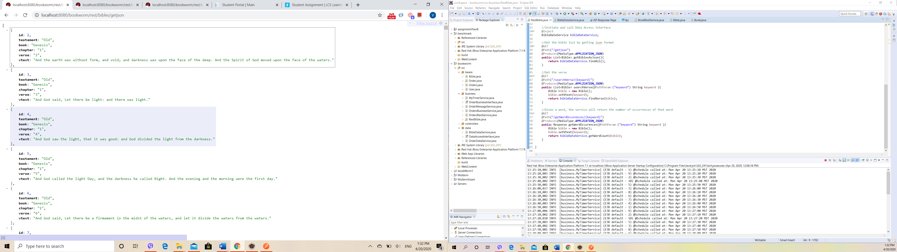

**Find the bible information as book, chaper, verse by sending a keyword to the Rest service.**

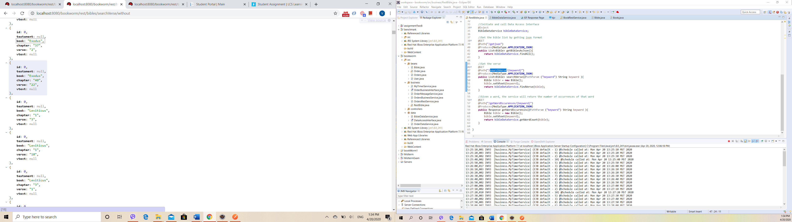

Get number of occurrences word from the bible

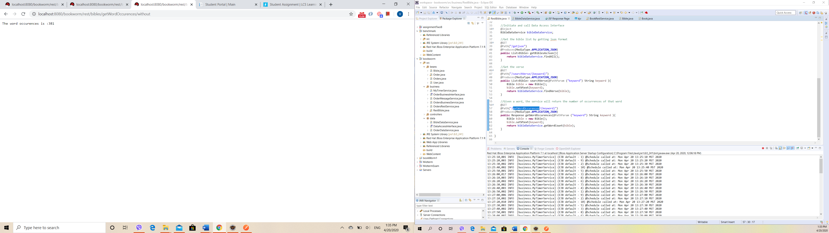

Bible data base.

